Task: Sharing Files Between Two Computers Using LAN Cable

Saad Ahmad

20P-0051

**Sharing file in windows**

**Note:** **Turn off your Wi-Fi**

Connect the two PCs with the Ethernet cable.

**Configuring PC2:**

Open Control Panel from the start menu.

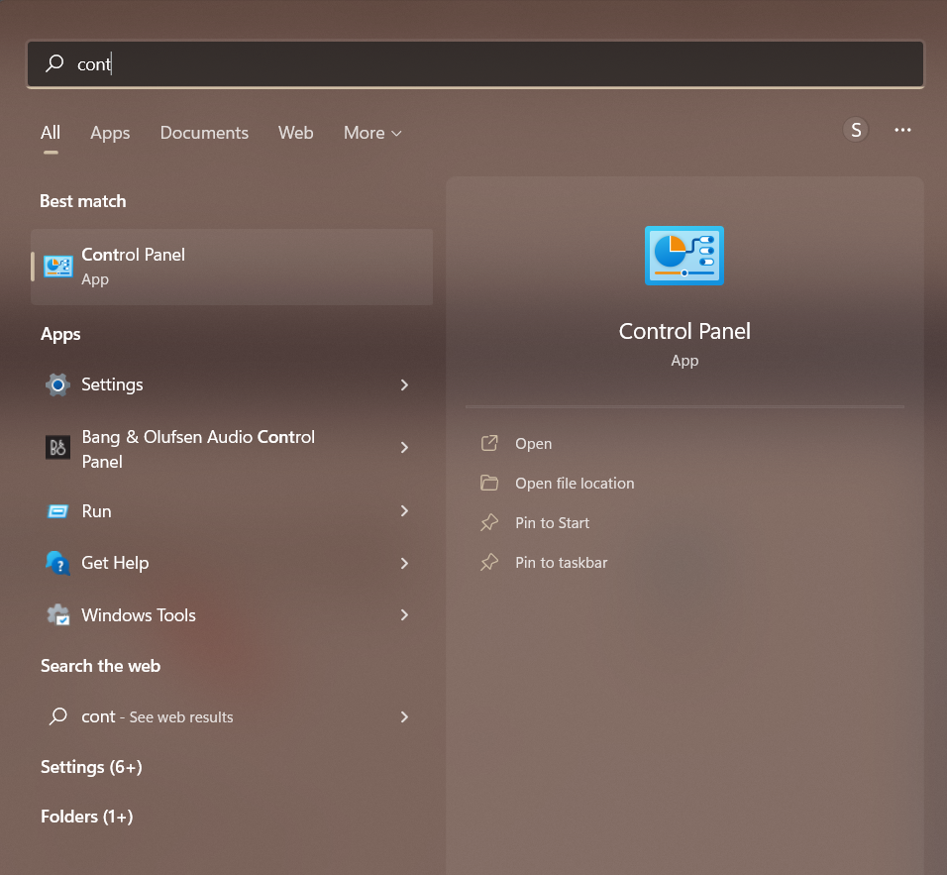

Now select the “Network and Internet”

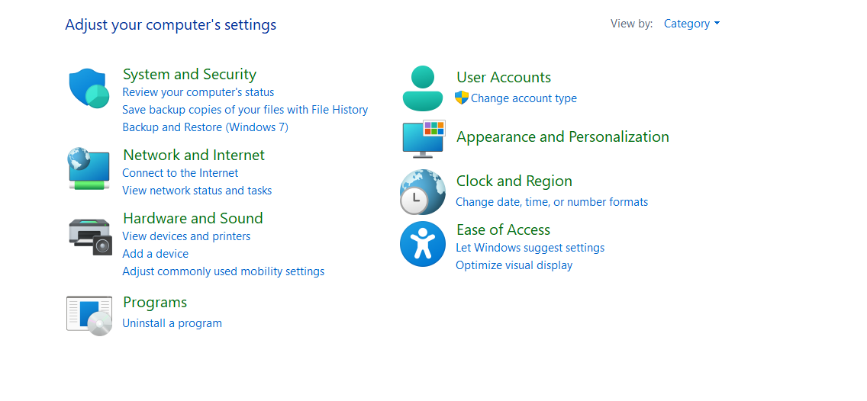

Now select the “Network and Sharing Center”

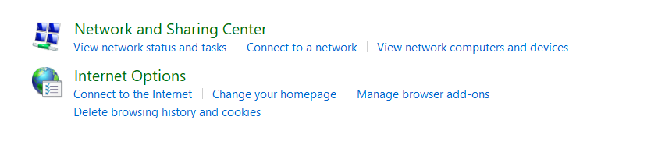

Now select the “Change advanced sharing settings” from the left menu.

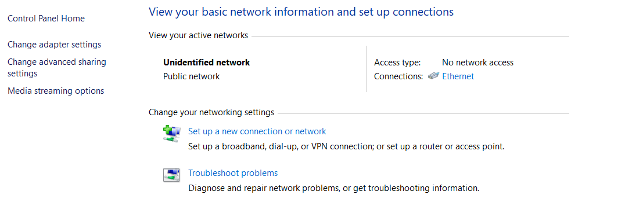

Now expand All Networks by clicking on the drop-down icon. Here, we need to enable Public Sharing so that the PCs can access files from each other over the LAN cable. To avoid more configuration, just Turn off password protected sharing. By doing so, you enable the other computer to access shared data without providing any credentials.

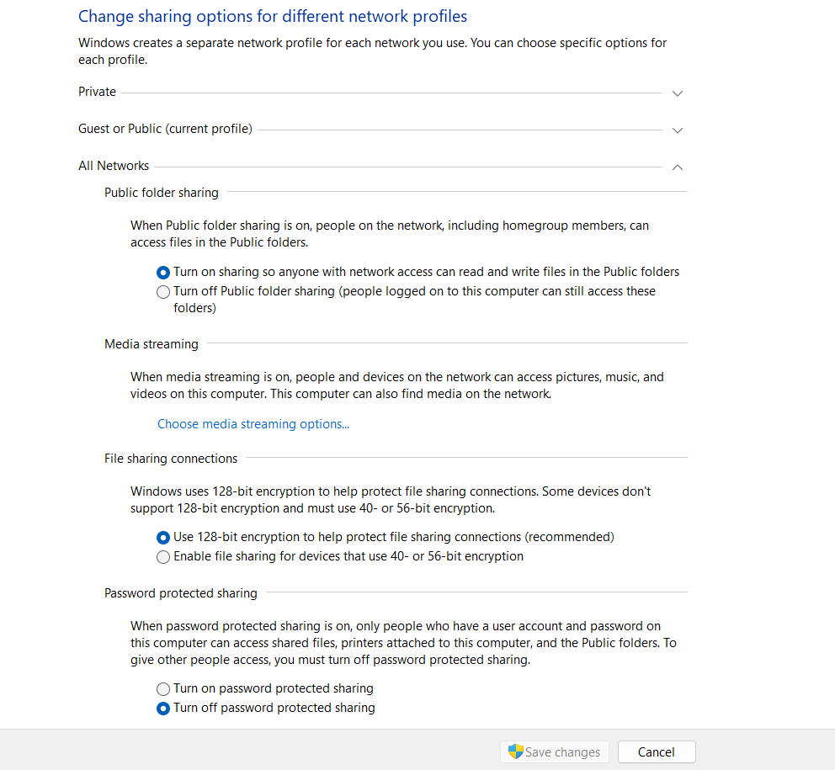

Now we will step up the static IP:

So, for that click on the Network and Sharing Center



Click on the Ethernet

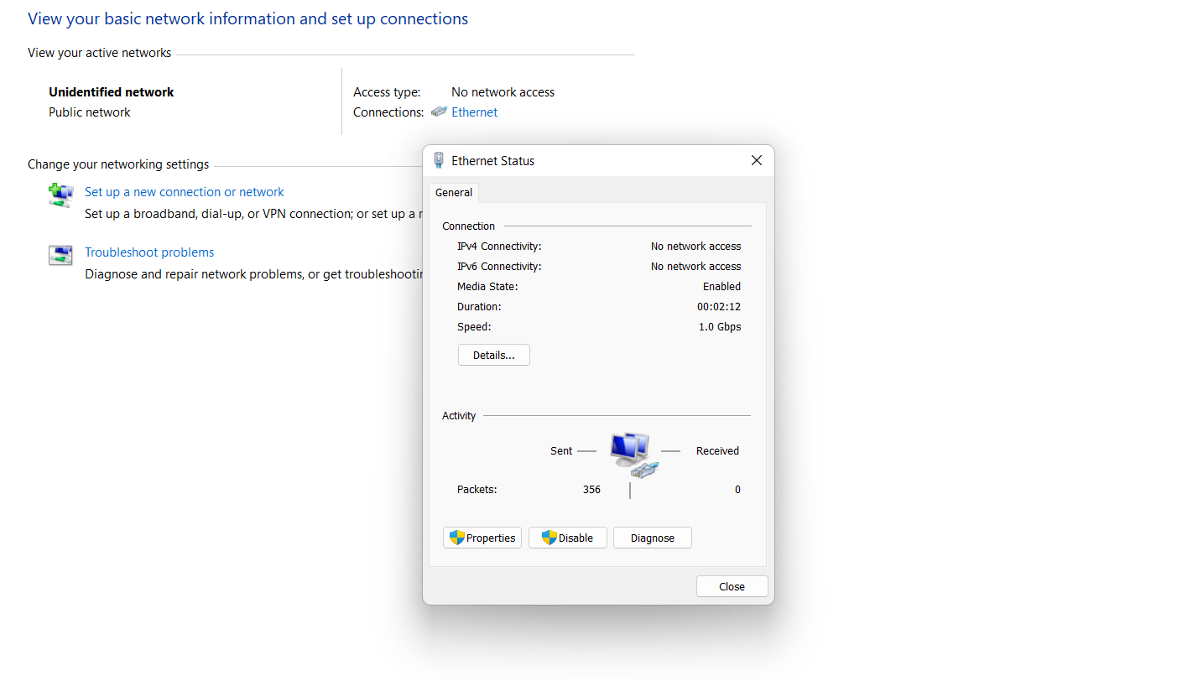

And now click on the properties

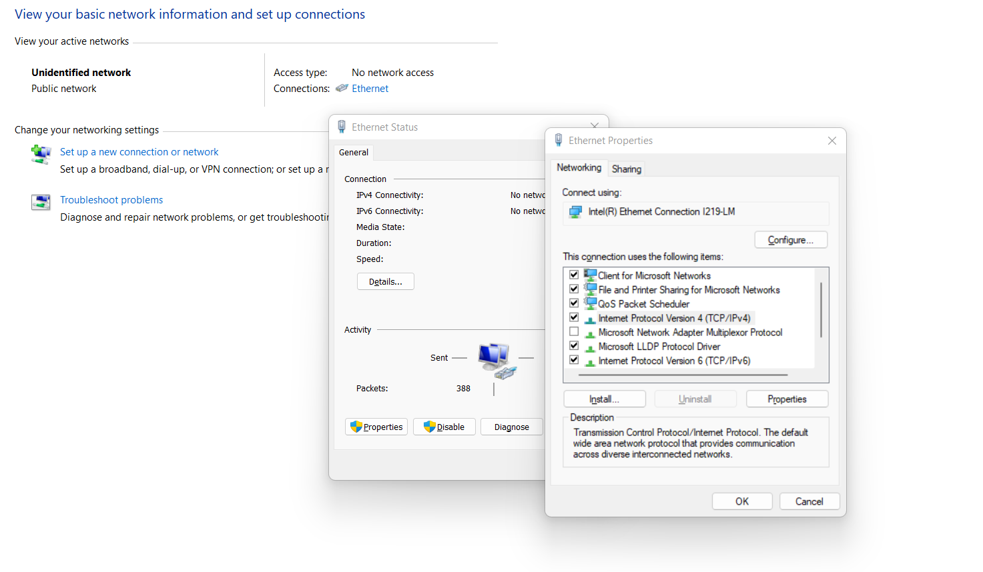

Now select the “Internet Protocol Version 4 (TCP/IPv4)” and open its properties assign the static IP to the PC.

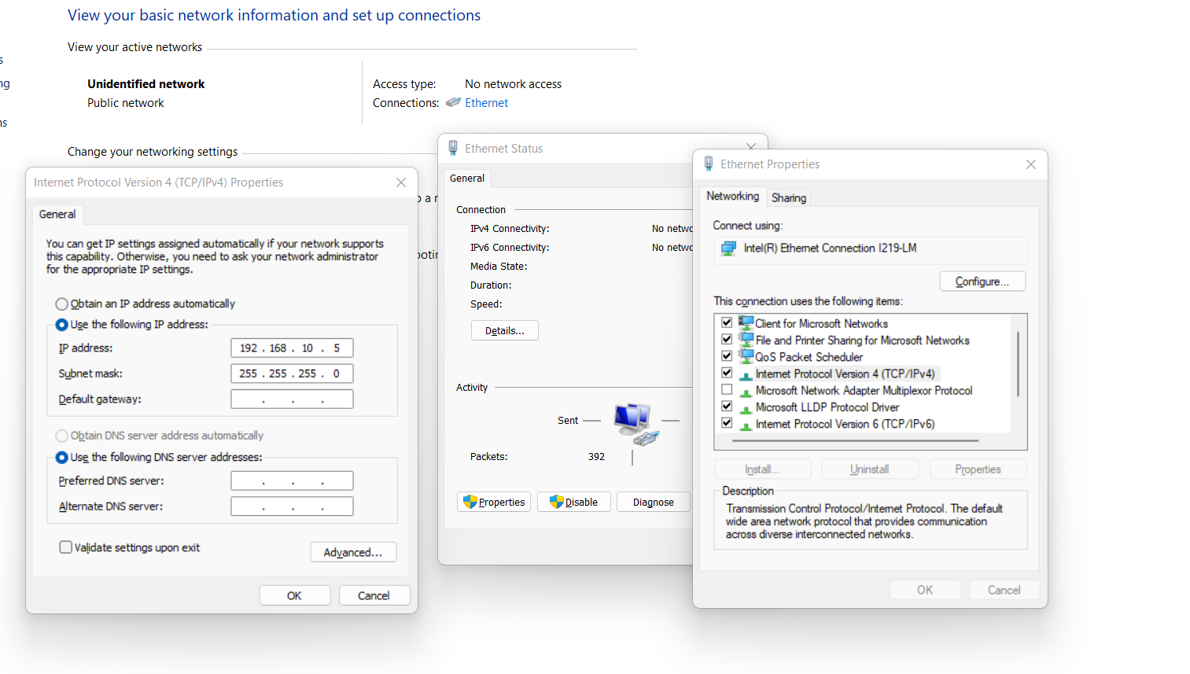

**Configuring PC1:**

Open Control Panel and select “Network and Internet”.

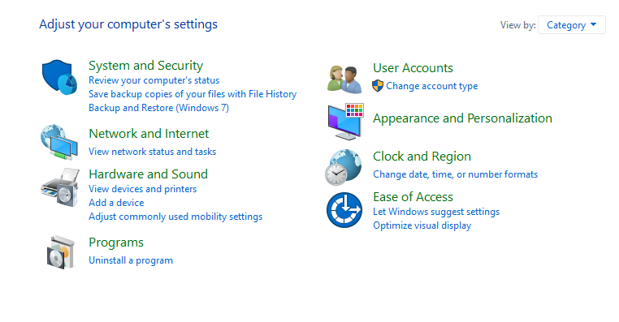

Now select the “Network and Sharing Center”

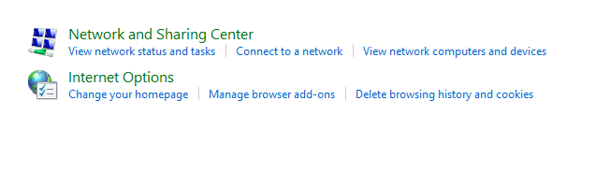

Now select the “Change advanced sharing settings” from the left menu.

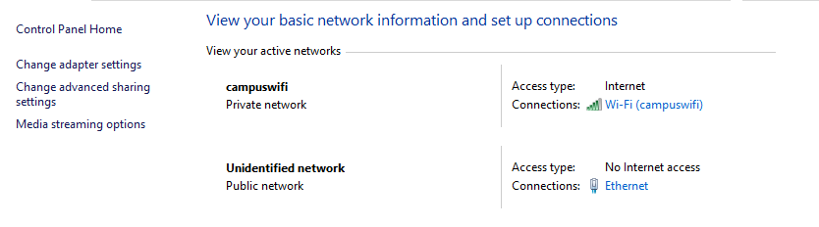

Now expand All Networks by clicking on the drop-down icon. Here, we need to enable Public Sharing so that the PCs can access files from each other over the LAN cable. To avoid more configuration, just Turn off password protected sharing. By doing so, you enable the other computer to access shared data without providing any credentials.

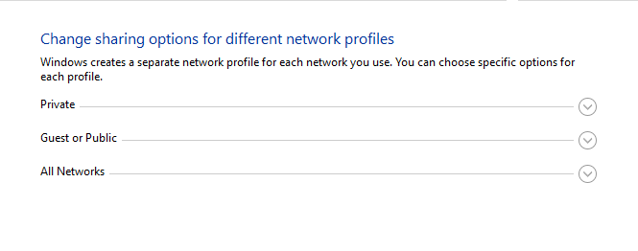

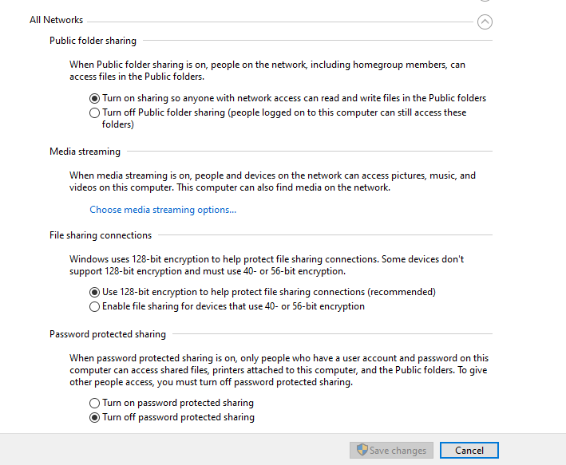

Now we will step up the static IP:

So, for that click on the Network and Sharing Center



Click on the Ethernet



And now click on the properties

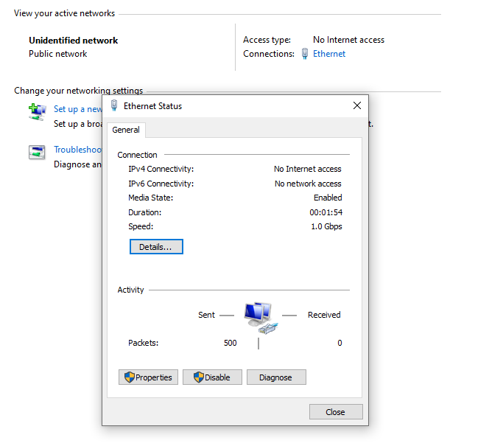

Now select the “Internet Protocol Version 4 (TCP/IPv4)” and open its properties.

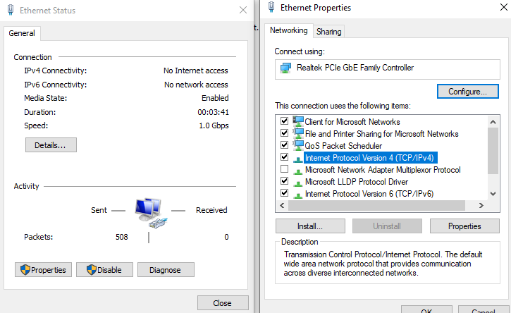

Now assign the static IP to the PC.

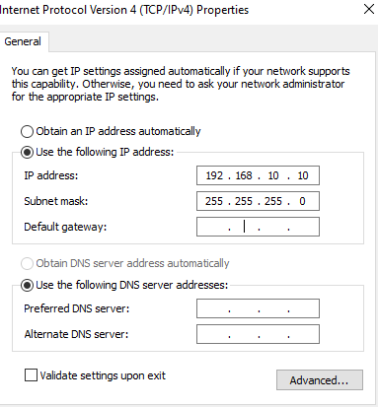

**Sharing file between two laptops:**

Create a folder and give access to it.

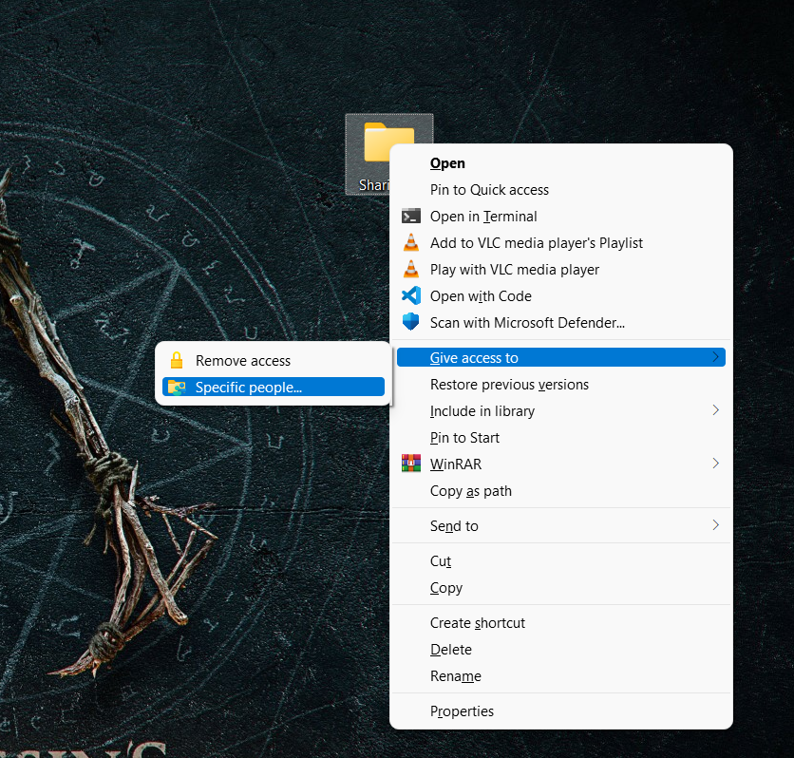

Now add the “Everyone” to the network access and click **share.**

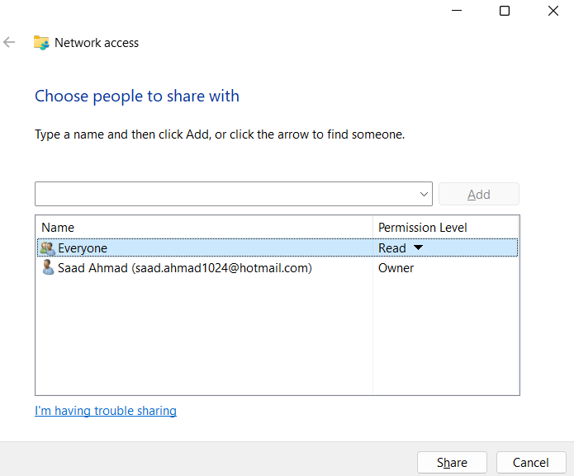

Now go to the This PC and select Network and there you will see 2 PCs.

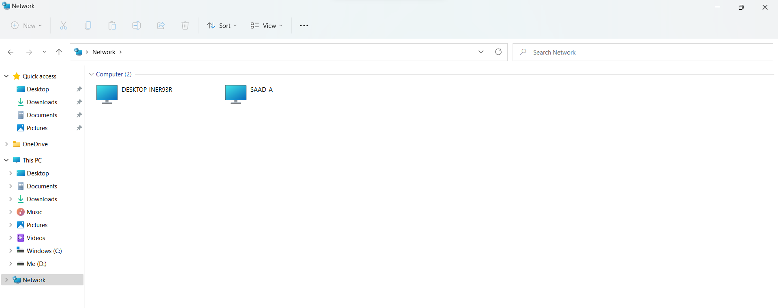

And now open the shared pc and you will see the folder which you had shared.

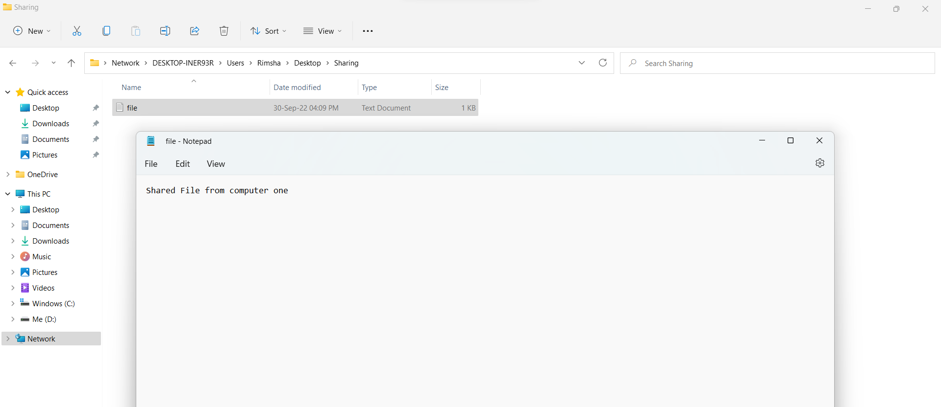

**Sharing files in Linux:**

To share the file first install vsftpd so for that run the following command:

sudo apt install vsftpd

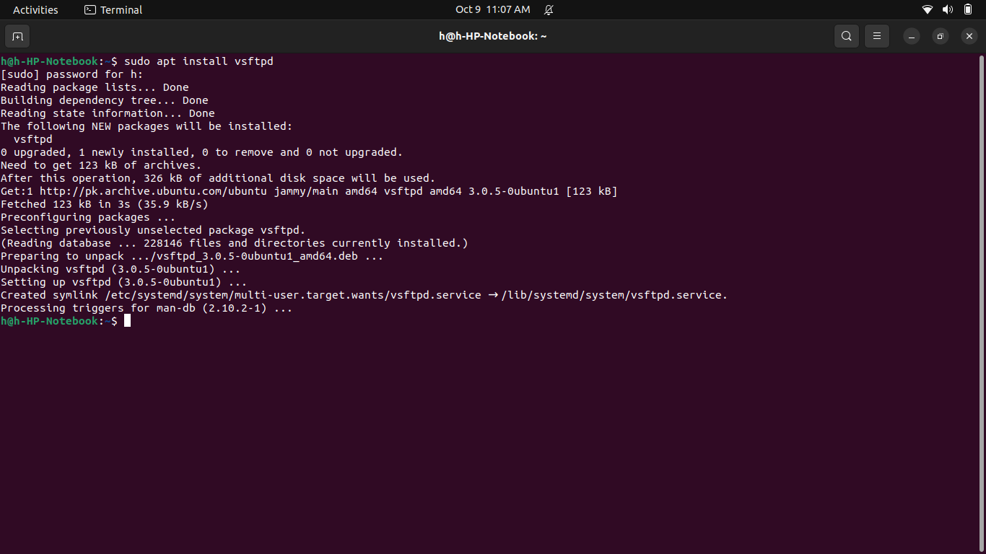

Now we will configure the vsftpd sever:

So, for that run the following command on the terminal

**sudo mv /etc/vsftpd.conf /etc/vsftpd.conf_orig**

**sudo nano /etc/vsftpd.conf**

and now copy the following content in the file.

**listen=NO**

**listen_ipv6=YES**

**anonymous_enable=NO**

**local_enable=YES**

**write_enable=YES**

**local_umask=022**

**dirmessage_enable=YES**

**use_localtime=YES**

**xferlog_enable=YES**

**connect_from_port_20=YES**

**chroot_local_user=YES**

**secure_chroot_dir=/var/run/vsftpd/empty**

**pam_service_name=vsftpd**

**rsa_cert_file=/etc/ssl/certs/ssl-cert-snakeoil.pem**

**rsa_private_key_file=/etc/ssl/private/ssl-cert-snakeoil.key**

**ssl_enable=NO**

**pasv_enable=Yes**

**pasv_min_port=10000**

**pasv_max_port=10100**

**allow_writeable_chroot=YES**

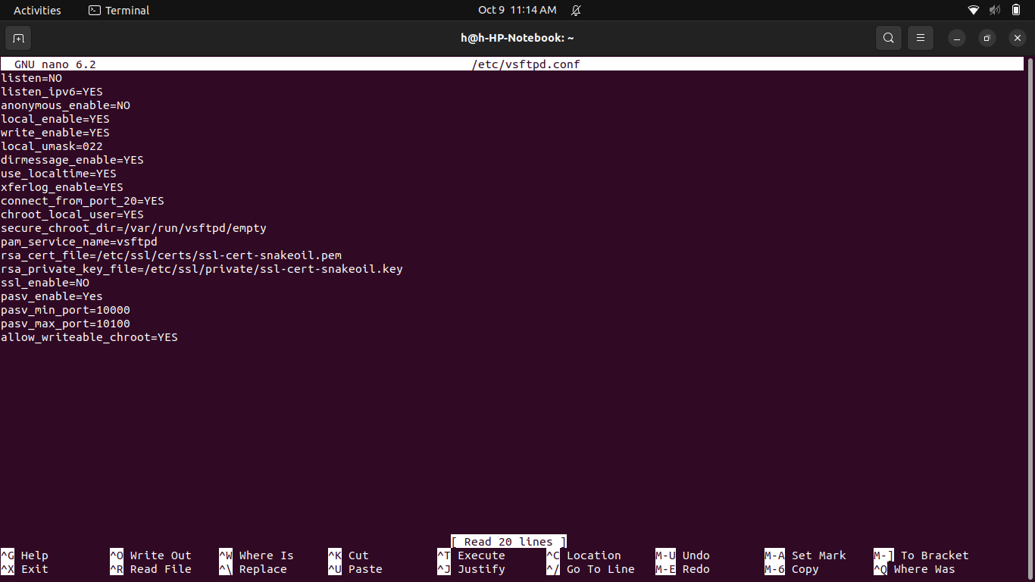

And save the file.

Now disable the firewall

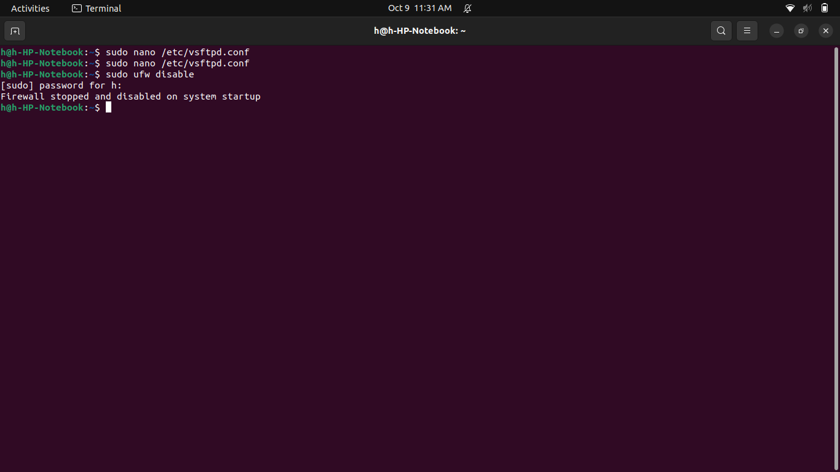

Restart the server

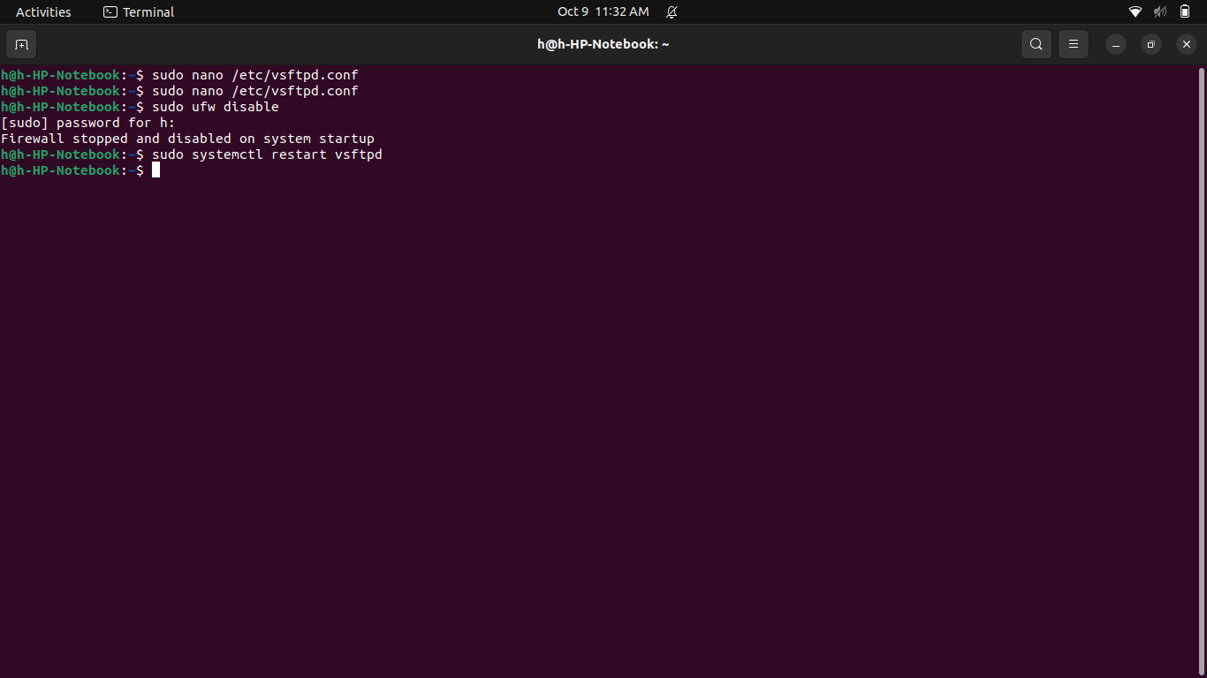

Create ftp user using following commands

sudo useradd -m ftpuser

sudo passwd ftpuser

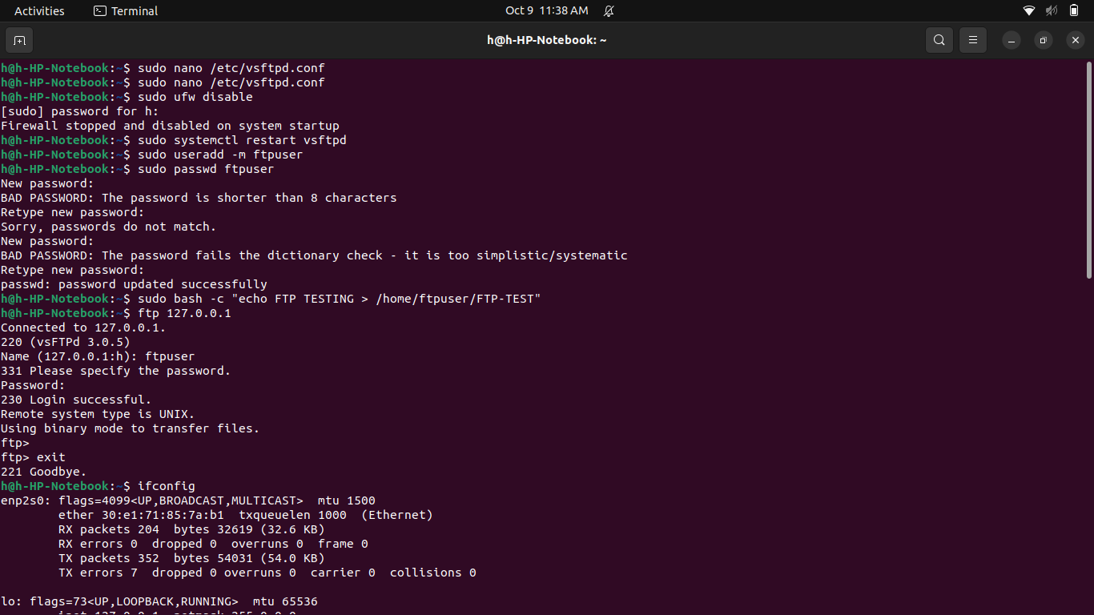I gave password 12345678

Now you can go to File explorer and Open Windows Network and click on Windows Network

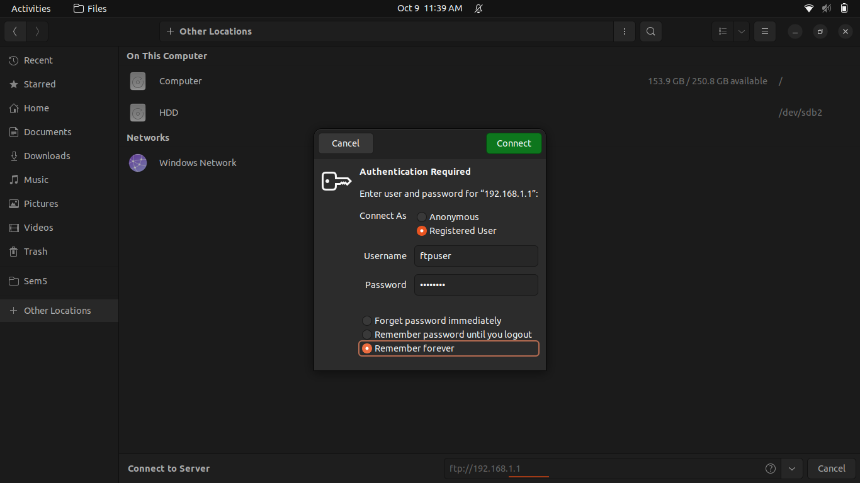

Password: 12345678

You can log in with 2nd system using same method as above.

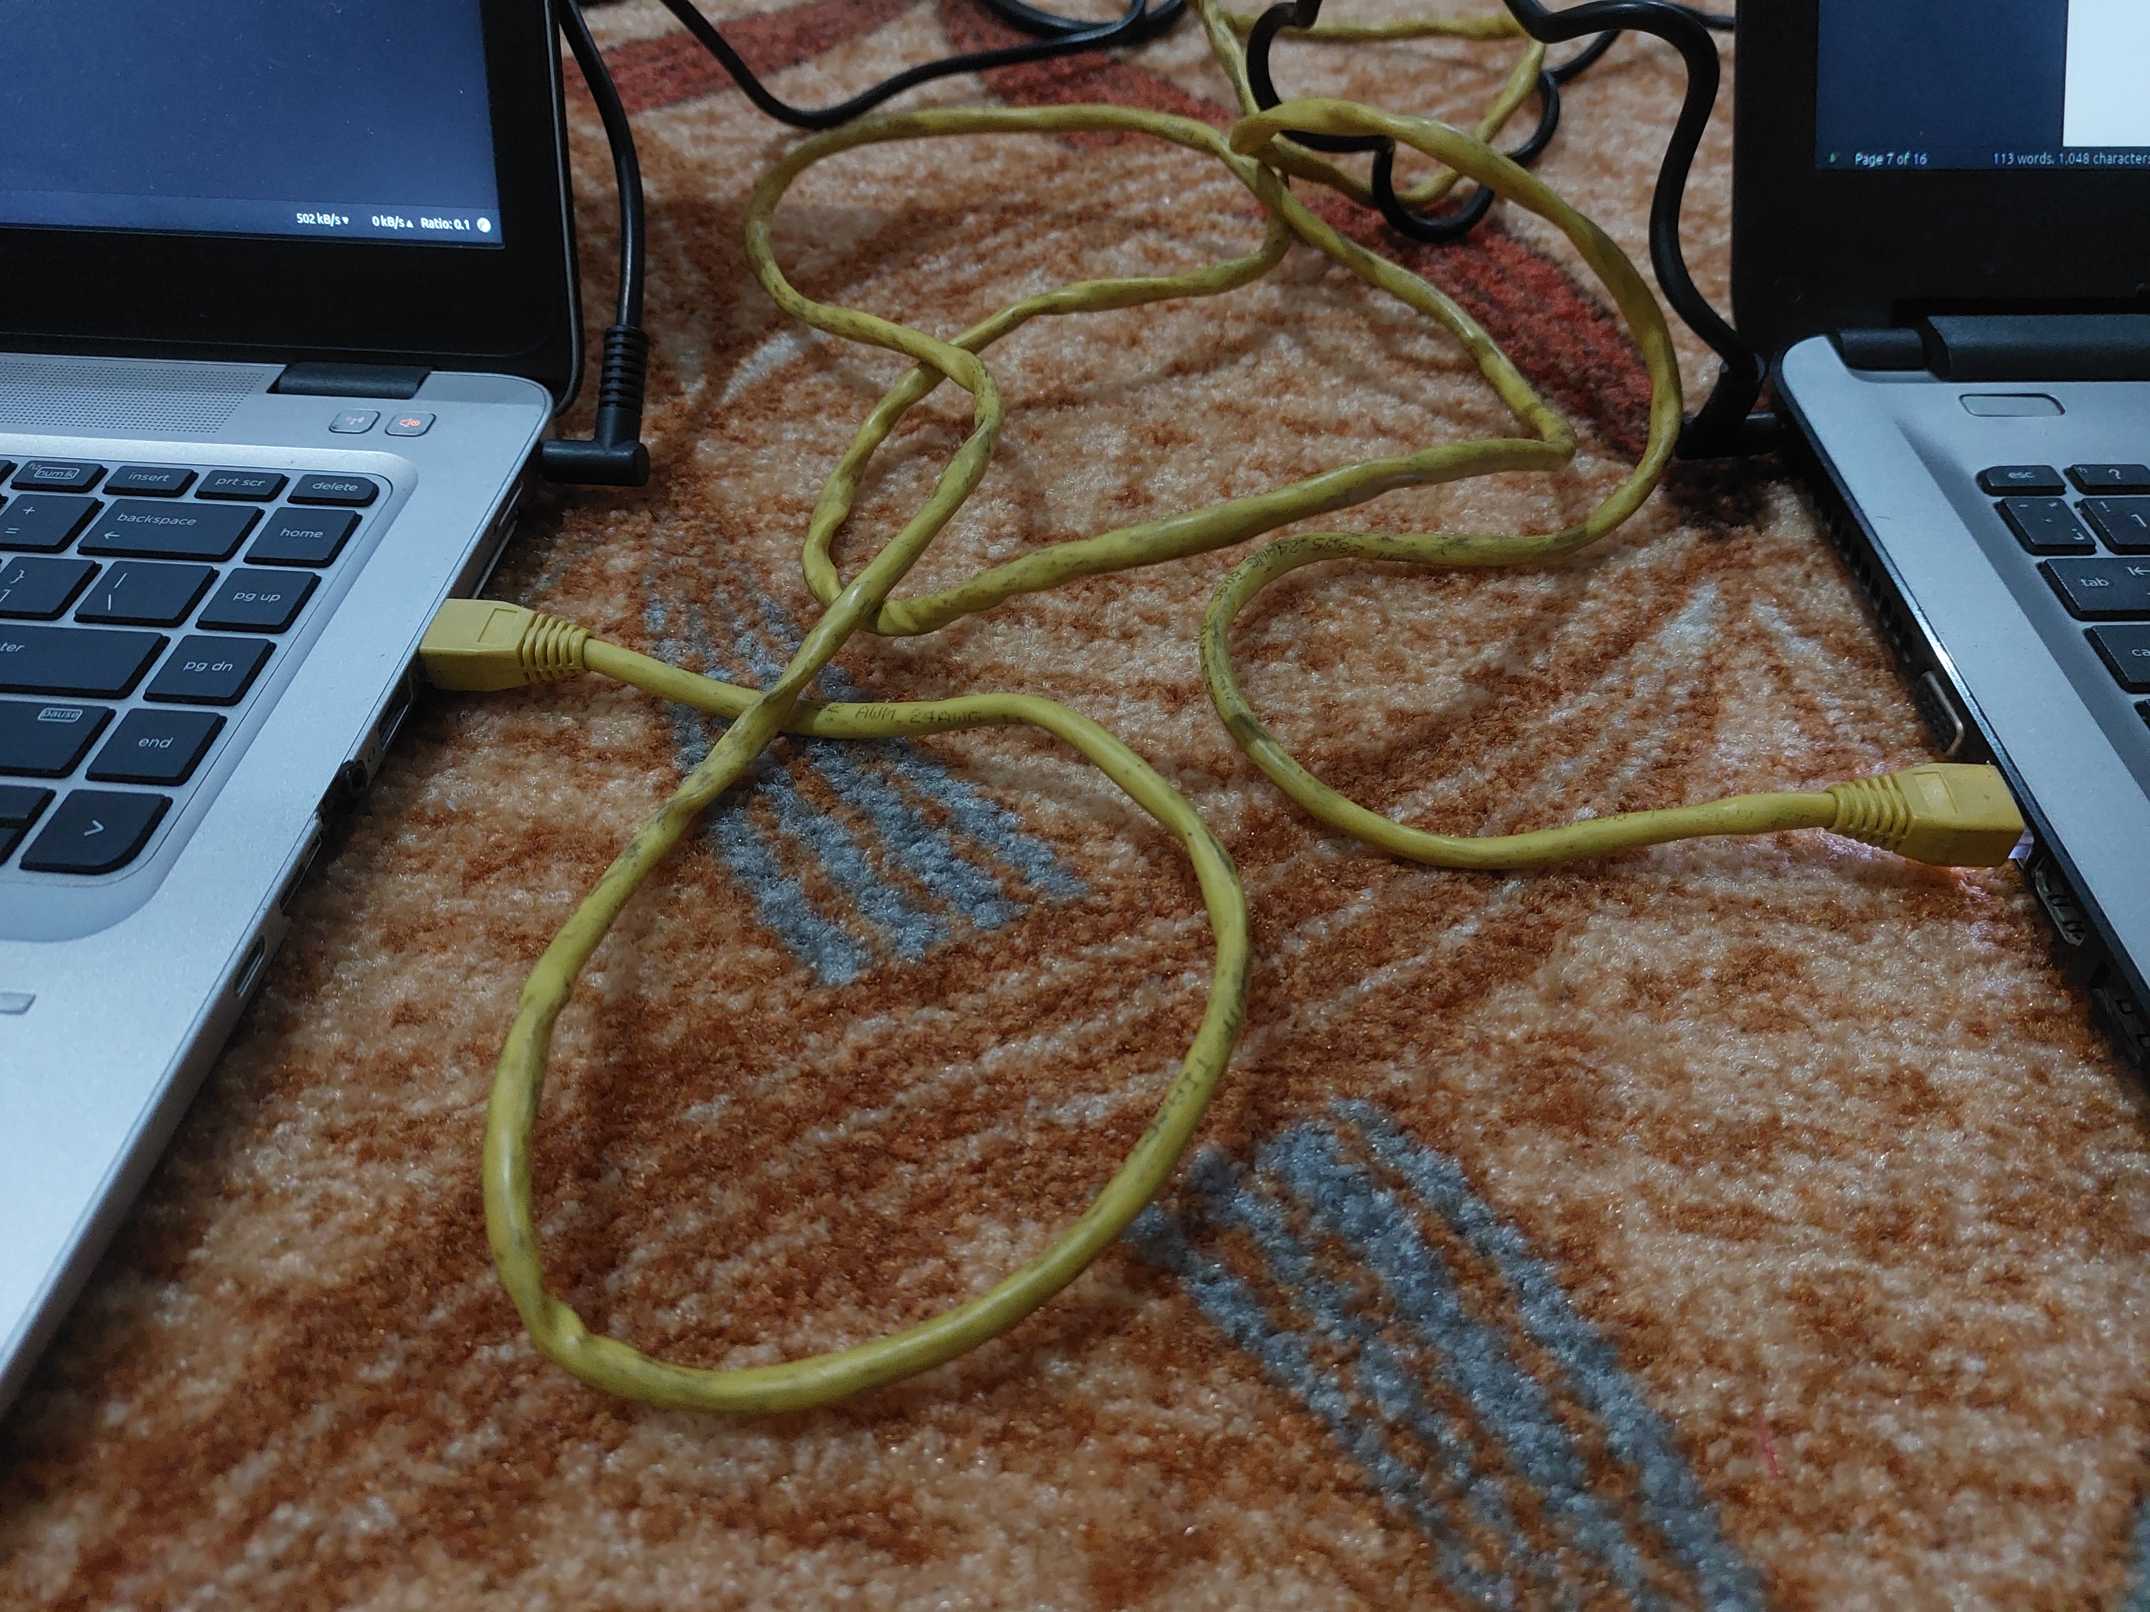Connect two systems

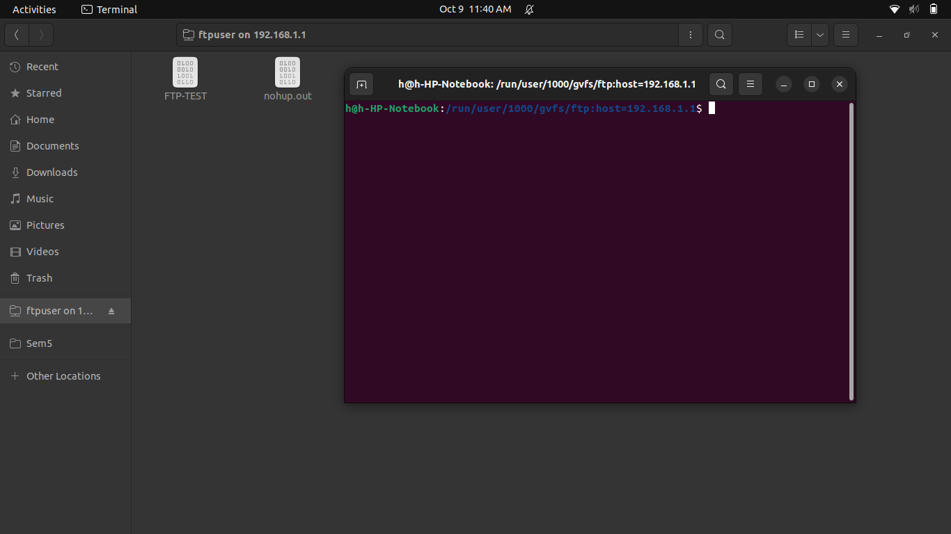Accessing the file from PC1

Accessing the file from PC2

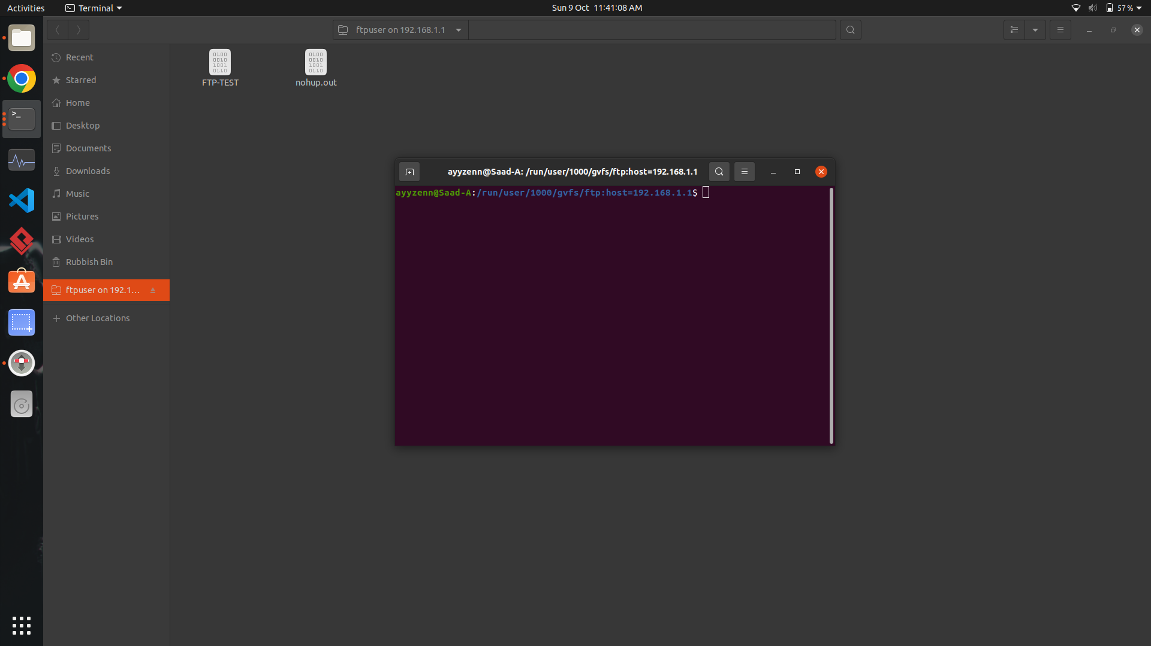

After adding some other files

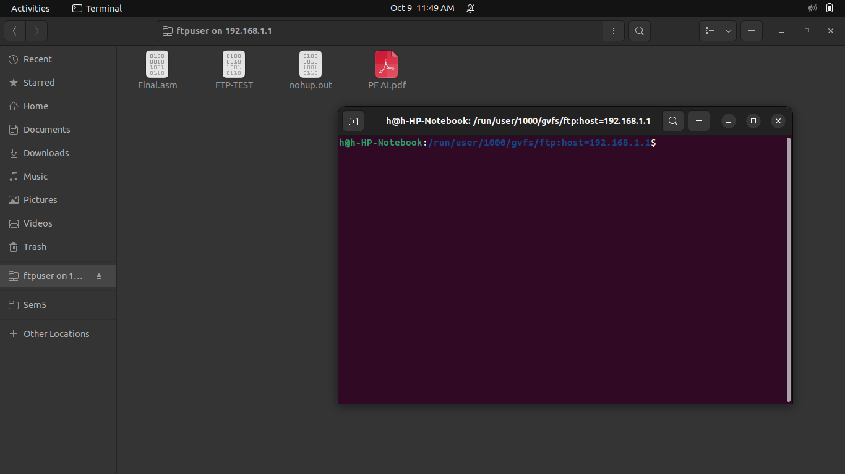PC 1

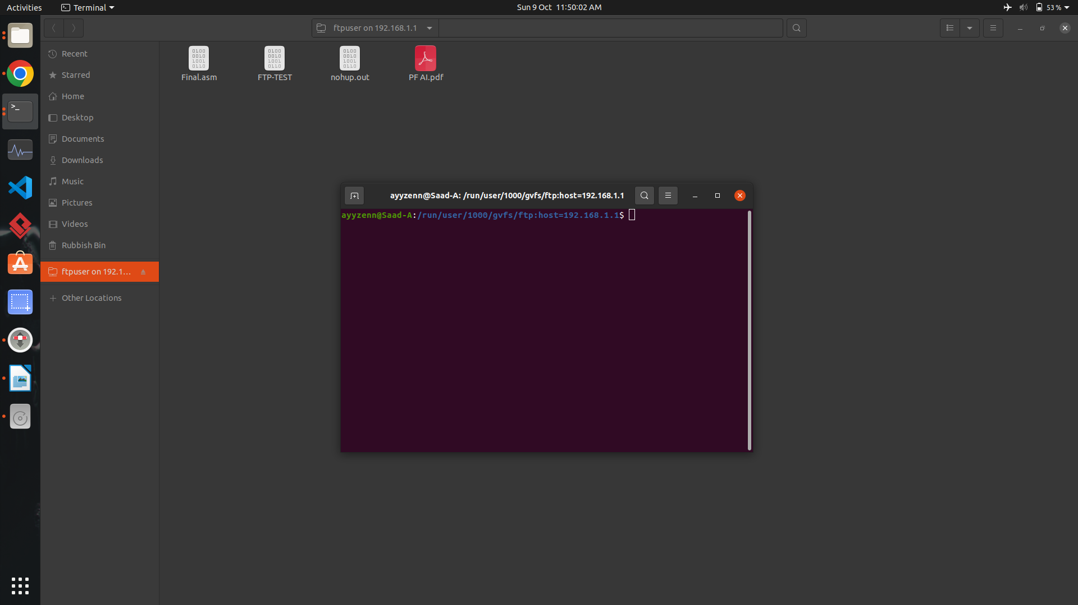PC 2